**DESIGN DOCUMENT**

**Product Name: Online Marketplace Web Application**

**Date: 12/09/2016**

**Version: 2**

**Project Group 3:**

**Tyler Citrin and Jason Pfau**

**INDEX**

1. **Introduction**……………………………………………………………………………………3
   1. Purpose...………………………………………………………………………………….3
   2. Scope….…………………………………………………………………………………..3
   3. Definitions...…………………………………………………………………………….3-4
   4. Overview.....………………………………………………………………………………4
2. **General Description**
   1. Tools and Technology.....…………………………………………………………………5
   2. Assumptions.....…………………………………………………………………………...5
3. **Architecture**
   1. Class Overview.....………………………………………………………………………..5
   2. Database Design………………………………………………………………………….5
   3. Class Diagrams.....………………………………………………………………………..5-6
   4. Activity Diagrams.....……………………………………………………………………..7-8
4. **Instructions**
   1. Package Structure.....……………………………………………………………………..9
   2. Instructions………………………………………………………………………………10
5. **Introduction**
   1. **Purpose**

The project will mimic an online marketplace system like Amazon, which allows sellers to provide an inventory of items to be sold; buyers to be able to purchase those items; and the Marketplace to keep track of shipped items. This simplified system (“mini-amazon”) can be visualized through the perspectives of a seller, buyer, and administrator.

* 1. **Scope**

The user(s) should be able to sort through a small list of items presented to him or her through a few sellers.

* 1. **Definitions**

|  |  |
| --- | --- |
| Element | Description |
| Buyer | Buyer should be able to register their account with the market place and each buyer will have a unique ID, name, email. Buyers should be able to view the current inventory available for sale and should also be able to search for a particular item by name or ID. Buyer is allowed to purchase any item (if the quantity is available). |
| Seller | The sellers should be able to register themselves with the Marketplace (and they will be issued unique seller ID, passwords, and contact email address). Once registered, seller will be able to upload the inventory of items available for sale. Each item will have the following attributes: unique item number, item name, brief description, seller ID, quantity and price. Seller should be able to manage the inventory (i.e., show current inventory, increase or decrease quantity, change price, update description of item, but not the seller ID). |
| Administrator | Marketplace administrator should be able to see the list of buyers, sellers, and generate reports like inventory by selected seller, buyer purchase history, sales history (on any specific day or within last week or month), shipping status of any item, etc. Administrator should also have access to update any seller and buyer account details as well as update any inventory item. |
| Marketplace | The marketplace system is responsible to make sure that the inventory is properly maintained. It also ensures that the item is shipped upon the sale of the item. At any time, Marketplace Administrator should be able to check any attribute regarding sellers, buyers or items |
| Item | What is available for purchase, containing information such as a number, name, description, category, price, seller-id, etc. |
| Inventory List | A list of items, with basic information needed to make a purchase. |
| Person List | A list of either buyers or sellers to be used by the marketplace administrator. |

* 1. **Overview**

Both buyers and sellers will register and login to the system to ensure verified access. Buyers will search through and order items. Sellers will keep track of their items and ship items upon purchase. The marketplace administrator will oversee everything including inventory and the user-base.

**Buyer:**

* A buyer registers and then logs in.
* The buyer is then given a list of options to take such as search or purchase items.

**Seller:**

* The seller registers and then logs in.
* The seller is given a list of options such as add, edit, update items.

**Administrator:**

* The administrator logs in.
* The administrator is given a list of options such as view inventory or person lists.

1. **General Description**
   1. **Tools and Technology**

**We will be using:**

* Java 8
  1. **Assumptions**

The user has access to:

* The user has access to a keyboard and mouse

1. **Architecture**
   1. **Application Flow Overview**

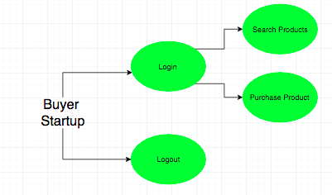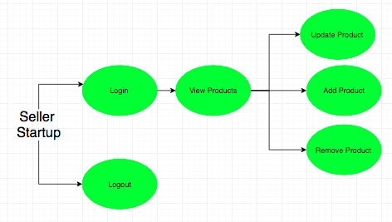

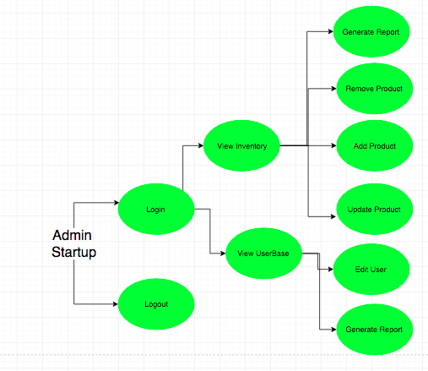

* 1. **Database Design**
  2. **Class (UML) Diagrams**
     1. **Initial UML**

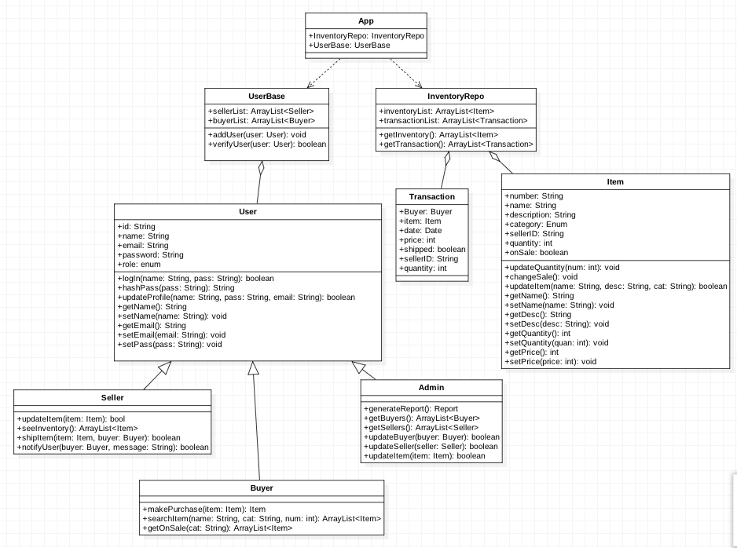

* + 1. **Final UML**

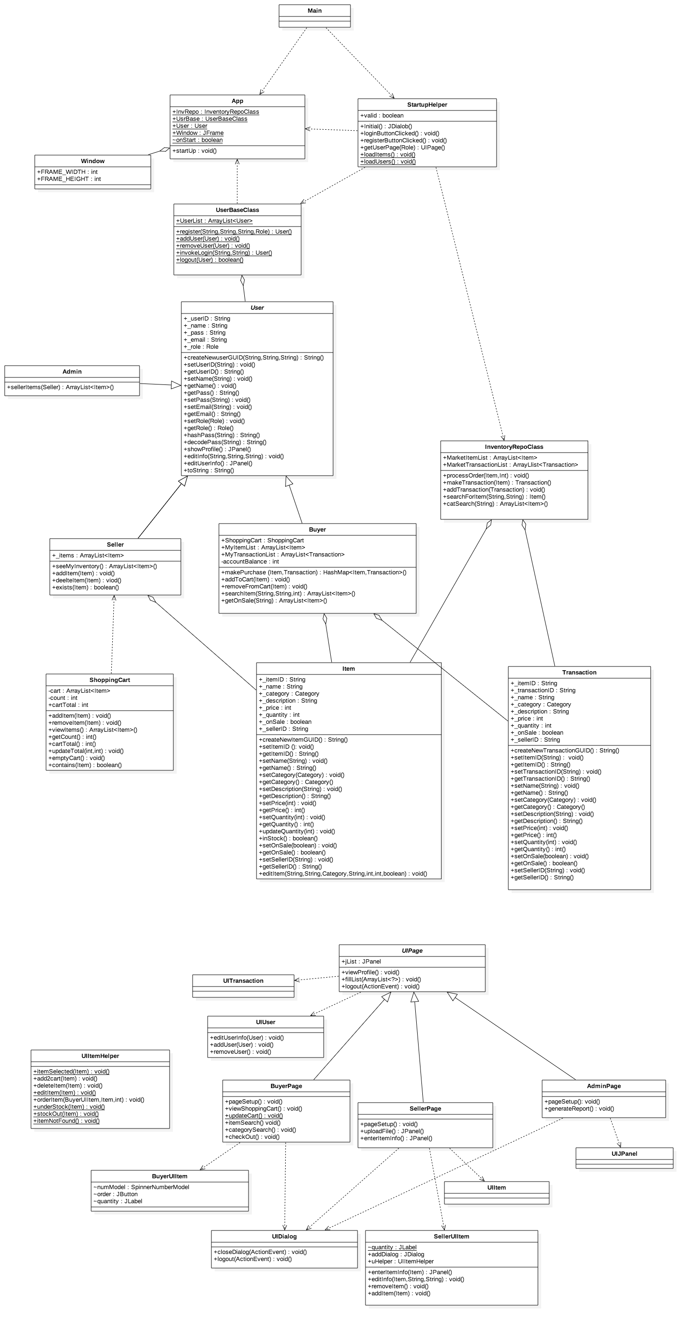

**4.1 Package Structure**

**- src**

**- inventoryrepo**

- Item

- InventoryRepoClass

- Transaction

- ShoppingCart

**- navigation**

- App

- StartupHelper

- Window

**- ui**

**- helpers**

- UIItemHelper

**- pages**

- AdminPage

- BuyerPage

- SellerPage

- UIPage

**- renderers**

- UIDialog

- UIJpanel

**- views**

- BuyerUIItem

- SellerUIItem

- UIItem

- UITransaction

- UIUser

- UserUIItem

**- userbase**

- Admin

- Buyer

- Seller

- User

- UserBaseClass

- Main

**- Images**

**- Files**

**4.2 Instructions**

This project was meant to be run in an IDE, but can be run via the command line via the main file for each type of user below.

**To run, run the main file.**

The user has the option to register as a new user or login. Each option consists of text entry and pushing a button with the corresponding choice.

The user is then given a new frame/page that will be in existence for the life of the app.

**Each user has intuitive options to choose from.**

**By closing the window, the program terminates.**